1. Provision of design documentation and test results (maximum. 2 pages).

Base

0

3

2

1

4

5

6

7

1

2

3

4

5

6

7

8

8

**Water not found, Skip**

**Water not found, Skip**

**Water not found, Skip**

Key

**No need to travel, water rock found**

Green Arrow – Returning direction to base

**Water Rock found**

Red Arrow – Travelling direction, looking for rocks

The way I have created the algorithm, is by giving Mars a maximum grid of 8(Up)x8(Side), as the maximum parameter edge of the grid for the Rover can travel up to. I have set FACTS for the rocks and placed them inside the grid. Four without water and one with water. The rocks will also have their position set inside the grid. For example, Rock #1 with no water has Up (2), and side (6) and it is inside the grid. Rock #2 (3,2), Rock #3 (5,3), Rock #4 (7,2). I have given the Rock with water (6,6). I have given the rover a base position of (0,0).

The agent will start to search for by travelling to the right side of the grid, then it will move one number to the top, and it will travel to the left side of the grid until it hits the edge and it will move one number to the top and keeps going until it has hit every edge of the grid, making sure rocks inside the grid are picked up and inspected for water, if found it will be taken to the base. I have done this by implementing WHILE loops for the rover, to keep searching for rocks until it hits every edge of the grid, if a rock is found then the rover will return VALUE TRUE = 1, which will execute the PLAN to go back to the base with the rock, if not VALUE is returned =0, which means the loop will continue until a rock with water is found or until the rover has travelled every edge of grid.

The whole algorithm depends on WHILE Loops: Loop to make the rover go right side, loop to make the rover go to the left side, loop to make the rover to go one number up the grid. I have set a condition where if direction is less than 5(fixed) value, then it will move to the right (rover’s starting direction is always less than 5, (0,1), then therefore it will first start with WHILE loop which will make the rover go to the right side of the grid by adding +1 to the right grid value position of the rover. Therefore, when it reaches to the end of the right grid the value will be (8,0), this will activate WHILE loop to move one number to the top, where if the rover’s position isn’t (8,8), then it will add +1 into the rover’s position, making it (8,1). This will activate WHILE loop to move to the left side of the grid, where it TESTs that rover’s new position is more than 0, which it is, it will keep substracting from the rover’s position (8,1) to (1,1). WHILE loops will make sure that the rover is travelling every edge of the grid, from right to one number top and all the way to the left and so on.

To PERFORM the PLANs, to find the rocks inside the Grid(Mars), WHILE loops are inserted inside the WHILE loops which are moving the rock to each side. If the rover finds a rock while travelling side to side, then it will PERFORM one PLAN from 5 different PLANs, depending on which Rock is found. For example, in the algorithm, the first rock is to found is Rock (3,2). When the rover finds the Rock, it will perform that Rock’s plan. If the rock’s location matches with the rock with water (6,6) then it will execute another plan to bring the rock back to the Rover’s base, because the water has been found =1 TRUE. If it doesn’t match, in this case it doesn’t, then it will put the rock back as it has no water in it and it will keep travelling until it hits another rock’s position in the grid.

Test Report

Testing Number 1: Testing to see if implemented algorithm finds the water with rock or not. This is done to make sure that the algorithm will travel from the right side of the grid, keep going until the rover’s position is (6,6) therefore finding the rock with water and analysing the rock for water, when water is found set the water status to ==1 TRUE, therefore return to base plan is executed. This was the expected outcome and that was the outcome that was achieved. This made sure that It did not return the rocks without water (2,6), (3,2), (5,3) to the base. Didn’t get to the rock with (7,2) because rock with water was found therefore it did not need to travel to (7,2) which makes sense because the while loop should end if water has been found ==1 TRUE.

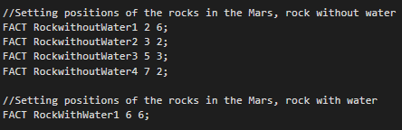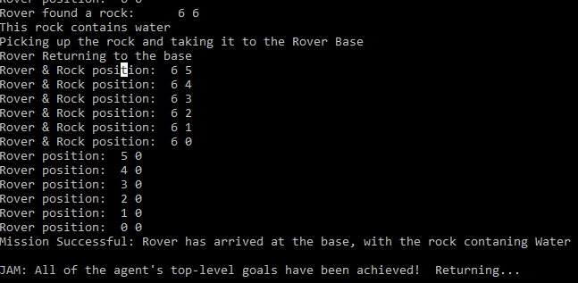

Testing Number 2: Adding another Rock with water but placing it before the new rock in the grid before the old one, therefore the expected result should be that the rover finds the second rock with water first because it’s first in the grid (4,4). This was the expected result because the strategy was to find the closest rock with water and bring it back to the base. The outcome was as expected, this means that the rover will take significantly less time because the rock is closer to the base than the other one, this means it would have to travel less and the return path would be much closer to the base in the grid.

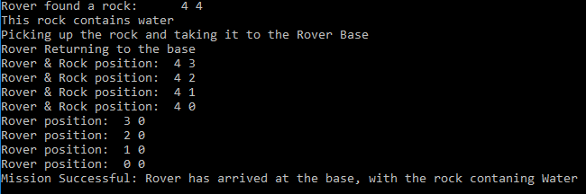

Testing Number 3: All Rocks have no water in them. This is to make sure that the Rover will explore the whole grid, making sure that rock is checked inside the whole grid. This was fundamental when creating the algorithm because this gave me an idea of how to make the rover move inside the grid and how can it move efficiently inside the grid without missing any rocks. I did this first time, when I implemented the algorithm because the first goal was for the rover to traverse the whole gird because it wouldn’t look for rocks at the end of the grid, if the rover was not travelling the whole grid (8,8).

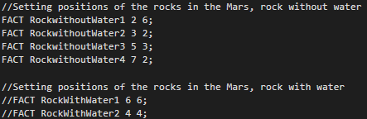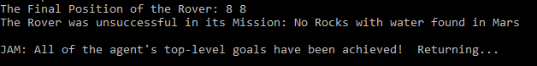

Testing Number 4: Testing to make sure that the rover doesn’t travel outside the grid when the any rocks, with or without water has been placed outside of the grid. This is not the mission of the rover or what the algorithm wants to achieve. If the whole grid(Mars) is 8,8. This is no way there would be any rocks outside of the grid therefore the rover should return to the base without finding any Rock with water. The outcome was as expected as the rover travelled to the edge of the grid (8,8) and ignored the rocks placed outside of the grid because it doesn’t make sense for the rocks to be outside of the grid if the whole mars is the (8,8).

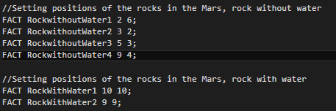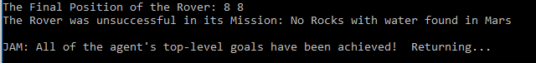

From these tests I can conclude, that the implemented algorithm to find rocks with water in Mars works as expected. The rover only traverses inside the grid and do not go outside the grid, which makes sure that the WHILE loop breaks and does not keep on going forever. I can also conclude from the tests that the Rover ignores the rocks without water and finds only the rock with water and returns to the base with the rock containing water. The rover will also return the base with nothing, if no traces of water is found on Mars.